|  |
| --- |
| PT. BERLIAN SISTEM INFORMASI |
| Operating Lease - Visit Customer Survey |
| **USER MANUAL GUIDE** |
|  |
| **VERSION 2.1** |
| **6/28/2016** |

|  |
| --- |
| All material contained in this manual including text, graphics, icons and images contain proprietary and confidential information of PT. Berlian Sistem Informasi and are protected by international intellectual property and other laws. The compilation of all text, graphics, icons and images in this Manual is the exclusive property of PT. Berlian Sistem Informasi. No modification, rental, lease, sale, transmission, distribution, reposting or creation or derivate works based on the material in this Manual is allowed, unless with the express permission of PT. Berlian Sistem Informasi. |

# REVISION HISTORY

|  |  |  |  |
| --- | --- | --- | --- |
| Date | Revision | Description | Author |
| 1/6/2016 | 0.0 | Initial Document | Sabilla Pravita Larassati |
| 3/2/2016 | 0.1 | Update document | AR. Anggun Cahyaningtyas |
| 3/16/2016 | 1.0 | 1st Baseline | AR. Anggun Cahyaningtyas |
| 5/8/2016 | 1.1 | Update document | Sabilla Pravita Larassati |
| 5/9/2016 | 2.0 | 2nd Baseline | Grand Zah Putra |
| 6/28/2016 | 2.1 | Revision 2nd Baseline | Alifa Karomina Putri |

# TABLE OF CONTENT

REVISION HISTORY 2

TABLE OF CONTENT 3

MARKETING MODULE 4

1. VISIT CUSTOMER SURVEY 4

PREREQUISITES: 4

1.1. Show List of Visit Customer Survey 5

1.2. Filter and Sort Visit Customer Survey Data 6

1.3. Create New Visit Customer Survey Report 7

1.4. Edit Visit Customer Survey Data 13

1.5. View Visit Customer Survey Data 16

1.6. Print Form Visit Customer Survey 18

1.7. Print Visit Customer Survey Report 20

# MARKETING MODULE

Operating Lease Support System includes Marketing Module features; Calculation of Operating Lease, Quotation of Operating Lease, **Visit Customer Survey, Board of Director Decree / SKD Process, and Agreement Information Inquiry**. All features will be described in the subsequent sections. The Marketing menu of Operating Lease Support System serves as the basic access to marketing module and records of all data. With the marketing menu, you will be able to utilize features of marketing module, including information that will be adjusted through other features of Operating Lease Support System.

Additionally you can enter a record, make changes, and inspect a detail record, and also filter specific records based on columns by writing a keyword on the search field. The features and data contained in your Operating Lease Support System menu are limited by your security and data authorization settings so you may not be able to access all features.

# VISIT CUSTOMER SURVEY

In the marketing process, the process starts when there is request from customer, and then DSF responded by offering the operating lease to customer. This process is called Bidding of Operating Lease which starts when the marketing officer plan to visit the customer. After the marketing officers have done surveying the customer prospect of operating lease business, they will have survey result. Based on the results, the officer can make an estimation or calculation including analysis and recommendation.

Visit Customer Survey module features support by recording every customer information and recommendation to be proposed to their management. In the Visit Customer Survey process provides several functions:

1. View detail of Visit Customer Survey and check the customer status for the Recommendation.
2. Filter and sort function.
3. Add new Survey Results, within save as draft and/or submit.
4. Modify the customer’s information; keep them up-to-date.

# PREREQUISITES:

Before user can start inputting the survey results, user has to login as Marketing Officer, then input the Customer Information and Product information in Master Data Information. (Refer to User Manual Phase 1.)

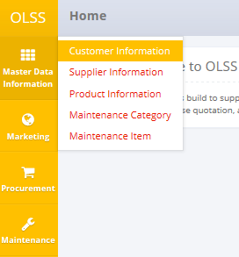

Screen 1: OLSS Master Data Information Menu

## Show List of Visit Customer Survey

At the beginning, user can open Visit Customer Survey screen by clicking the “Visit Customer Survey” on the list of Marketing Menu.

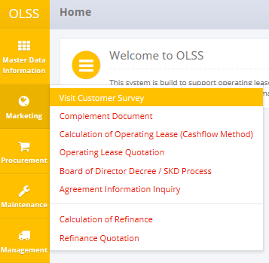

Screen 2: Marketing Menu

Once the menu is clicked, the system will display List of Visit Customer Survey screen that consist of Visit Survey results list that already recorded in the system. The main page of List of Visit Customer Survey is shown below:

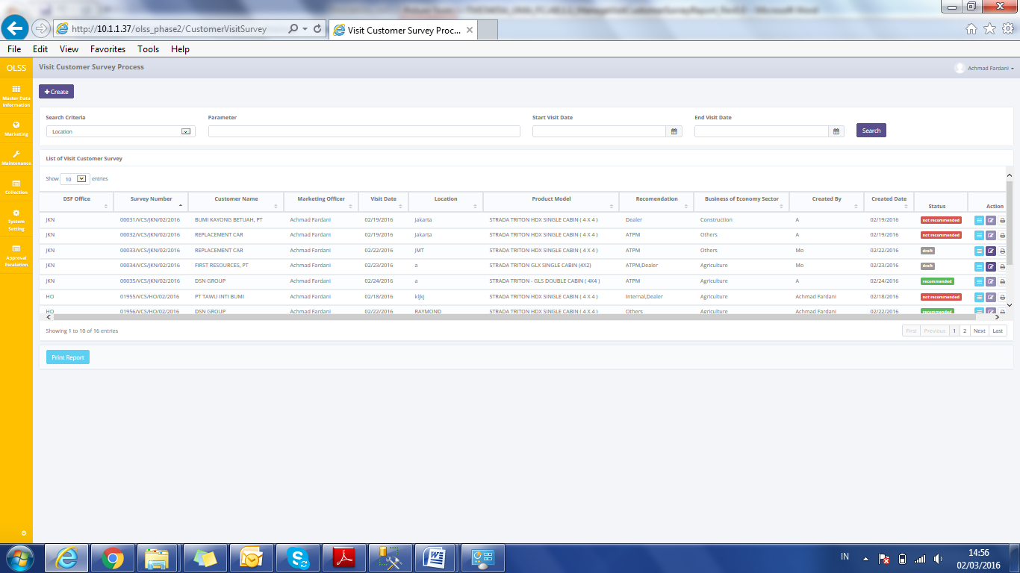

Screen 3: List of Visit Customer Survey

In the Visit Customer Survey process, the records will have several step of status when proceed by user. At the first time, when new survey added by user, the status will be saved as . After saved, the records can be submitted by user. Then the system will check the Recommended Field, if the field is filled with “Yes” value then the record will shown as C:\Users\bsi00357\Documents\Operating Lease\sabila bila ee waka waka ee\1-6-2016 11-04-30 AM.png which means the customer is recommended to be a customer for operating lease. If the field is filled with “No” value then the record will shown as C:\Users\bsi00357\Documents\Operating Lease\sabila bila ee waka waka ee\1-6-2016 11-04-57 AM.png which means the customer isn’t recommended to take Operating Lease.

## Filter and Sort Visit Customer Survey Data

To filter the records there are three categories as follows:

1. To sort the record alphabetically by column, user can click  on the column title on the table header.
2. User can select the number of records that want to be showed by picking this feature  on the screen. If the records have been filtered based on number, the amount of records that will be shown is the same as the selected number.
3. User can filter the records with the specific information by entering the keywords on the search field shown below:



Screen 4: Search Fields

Search criteria consist of data master:

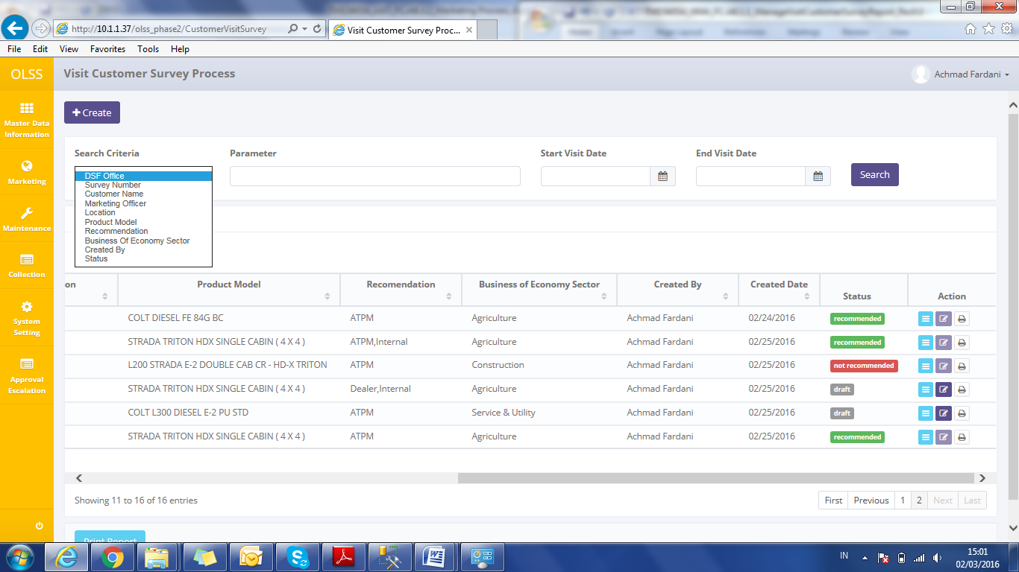

Screen 5: Search Criteria

Parameter can be filled with keywords that user want to search. To get more specific results, user can also insert the visit date (Start Visit Date and End Visit Date). For example, you can find name by filling the keywords in parameter, and pick **Customer Name** in Search Criteria, then pick the exact date, and press Search button to get the results.

## Create New Visit Customer Survey Report

To create new Visit Customer Survey data, find and click Create on top of the List of Visit Customer Survey Screen.

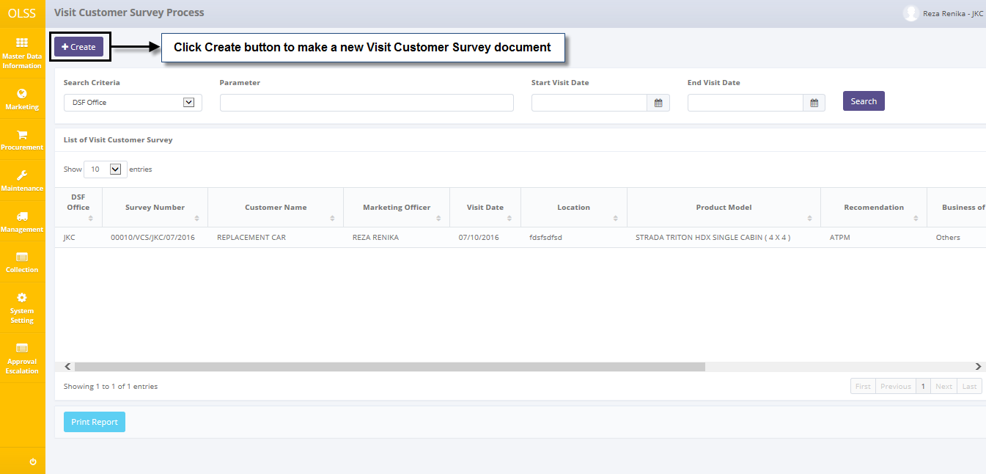

Screen 6: Navigate to Create from List of Visit Customer Survey

System will show Create Visit Customer Survey Screen shown below:

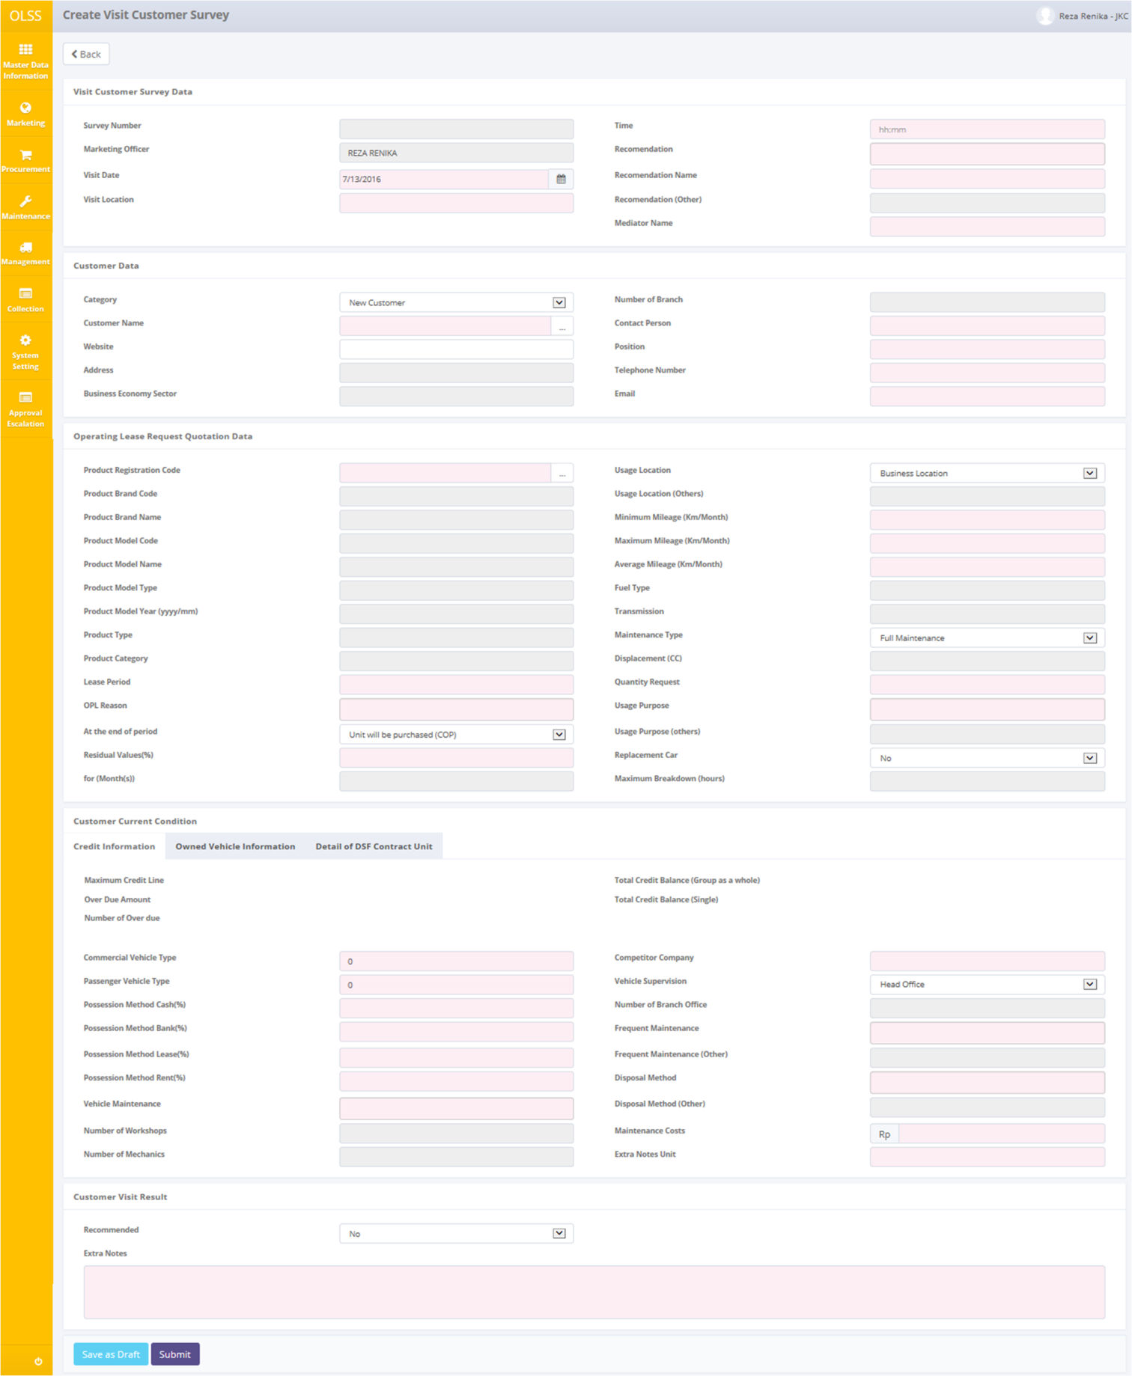

Screen 7: Create Visit Customer Survey Page

Once the Create Visit Customer Survey screens open, user has to fill information on the blank field. The fields are:

1. Visit Customer Survey Data
   1. Visit Date: select visit customer date, automatically set to current date.
   2. Visit location: input customer address that visited.
   3. Time: input visit time.
   4. Recommendation: pick any recommendation from other party such as: “ATPM”, “Dealer”, “Internal”, and “others”
   5. Recommendation Name: input recommendation name picked above.
   6. Recommendation Name (others): active if “Others” is picked on field Recommendation.
   7. Mediator Name: input middleman name.
2. Customer Data
   1. Category: Pick “New Customer” or “Repeat Customer”.
   2. Customer Name: Select customer that has been recorded in **Customer Information Module.**
   3. Website: input customer website.
   4. Address: customer’s address will be input automatically from the master data after selecting Customer Name.
   5. Business Economy Sector: customer business’ kinds will be input automatically from the master data after selecting Customer Name.
   6. Number of Branch: customer number of branch will be input automatically from the master data after selecting Customer Name.
   7. Contact Person: input name that can be contacted
   8. Position: input customer position
   9. Telephone Number: input customer telephone number
   10. Email: input customer e-mail
3. Operating Lease Request Quotation Data
   1. Product Registration Code: Select Product that has been recorded in **Product Information Module.**
   2. Product Brand Code: will be input automatically from product master data after selecting Product Registration Code.
   3. Product Brand Name: will be input automatically from product master data after selecting Product Registration Code.
   4. Product Model Code: will be input automatically from product master data after selecting Product Registration Code.
   5. Product Model Name: will be input automatically from product master data after selecting Product Registration Code.
   6. Product Model Type: will be input automatically from product master data after selecting Product Registration Code.
   7. Product Model Year (yyyy/mm): will be input automatically from product master data after selecting Product Registration Code.
   8. Product Type: will be input automatically from product master data after selecting Product Registration Code.
   9. Product Category: will be input automatically from product master data after selecting Product Registration Code.
   10. Lease period: input period in month.
   11. OPL Reason: reason why the customer want to use operating lease. Pick “down payment”, “off balance sheet”, “vehicle maintenance problem”, or “Value After Tax”. User can pick more than one.
   12. At the end of period: what the customer will do at the end of OPL period. Pick “unit will be purchased (COP)”, “unit will be extended”, or “replace with new unit”. User can pick more than one.
   13. Residual Values (%): input residual value. Field enable if you pick “Unit will be purchased (COP)” on field At the end of period.
   14. For ((Month)s): input month of unit that will be extended. Field enable if you pick “Unit will be extended” on field At the end of period.
   15. Usage Location: where the customer want to use the unit. pick “site” or “city”
   16. Usage Location (Others): field enable if you pick “Other” on field Usage Location.
   17. Minimum Mileage (Km/Month): the least mileage the unit used.
   18. Maximum Mileage (Km/Month): the furthest mileage the unit used.
   19. Average Mileage (Km/Month): the average mileage the unit used.
   20. Fuel Type: unit’s fuel type will be input automatically from product master data after selecting Product Registration Code.
   21. Transmission: will be input automatically from product master data after selecting Product Registration Code.
   22. Maintenance Type: pick “Full maintenance”, “limited”, “customer service desk”, or “non maintenance. User can pick more than one.
   23. Displacement (CC): displacement unit will be input automatically rom product master data after selecting Product Registration Code.
   24. Quantity Request: how many unit requested by customer.
   25. Usage Purpose: pick “transportation”, “operational”, or “others”.
   26. Usage purpose (others): active if “others” is picked on field Usage Purpose.
   27. Replacement Car: customer can pick if they need replacement car. Pick “yes” or “no”.
   28. Maximum Breakdown (hours): field enable if you pick “Yes” on field Replacement Car.
4. Customer Current Condition
   1. Credit Information
      * Maximum Credit Line: will be input automatically from customer master data (if any).
      * Overdue Amount: will be input automatically from customer master data (if any).
      * Number of Overdue: will be input automatically from customer master data (if any).
      * Total Credit Balance (Group as a whole): will be input automatically from customer master data (if any).
      * Total Credit Balance (Single): will be input automatically from customer master data (if any).
      * Commercial Vehicle Type: how much portions the vehicle customer have as commercial vehicle.
      * Passenger Vehicle Type: how much portions the vehicle customer have as passenger vehicle.
      * Possession Method Cash (%): how many percentage does a customer own the vehicle by cash.
      * Possession Method Bank (%): how many percentage does a customer own the vehicle by bank
      * Possession Method Lease (%): how many percentage does a customer own the vehicle by lease.
      * Possession Method Rent (%): how many percentage does a customer own the vehicle by rent
      * Vehicle Maintenance: pick “own workshop”, “authorized dealer”, and “non-authorized dealer”.
      * Number of Workshops: active if “own workshop” is picked on Vehicle maintenance.
      * Number of Mechanics: active if “own workshop” is picked on Vehicle maintenance.
      * Competitor Company: input customer competitor.
      * Vehicle Supervision: pick “head office” or “branch office”
      * Number of branch office: active if “branch office” is picked on field Vehicle Supervision.
      * Frequent Maintenance: pick “routine maintenance”, “tire”, “others”
      * Frequent Maintenance (others): active if “others” is picked on field Frequent Maintenance.
      * Disposal Method: pick “sell to employee”, “auction”, and “others”
      * Disposal Method (others): field enable if you pick “Others” on field Disposal Method.
      * Maintenance Costs: input how much the cost for selected maintenance.
      * Extra Notes Unit: input extra notes unit
   2. Owned Vehicle Information: automatically load up information from Customer Information
   3. Detail of DSF Contract Unit: automatically load up information from Customer Information
5. Customer Visit Result
   1. Recommended: Pick “Yes” or “No”.
   2. Extra Notes: Input reason why giving a recommendation or no recommendation.

There are three buttons that will be displayed on the screen as follows:

1. , on the top-left corner of the screen.
2. , on the bottom-left corner of the screen.
3. , on the bottom-left corner of the screen.

If data has been entered on the screen, user can save a data on the system by clicking **Save as Draft** button, or **Submit** button. Ensure that you actually want to **submit** a record, because the records can’t be reserved and update after submitted by user. Confirmation pop up will show if Save as Draft or Submit is clicked.

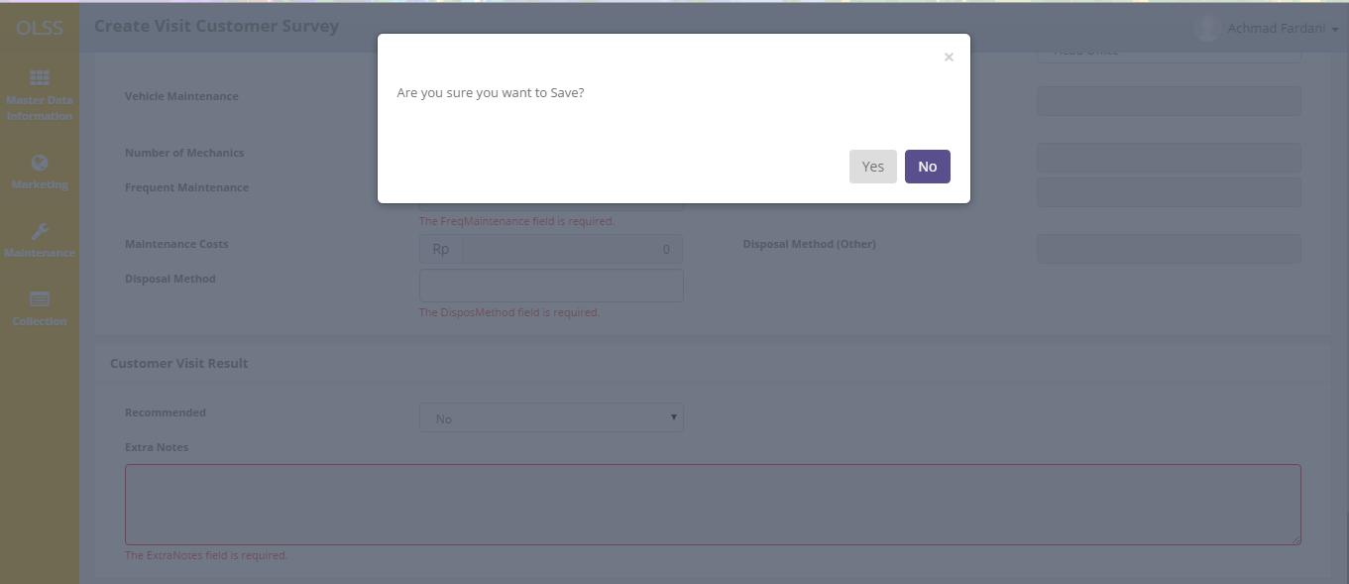

Screen 8: Confirmation pop up

There are mandatory fields marked with red background field that should be inputted including; visit location, time, recommendation name, visit date, and so on. It can’t leave as blanks. If you leave them blanks, system will notified it after you clicking **Save as Draft** or **Submit** button.

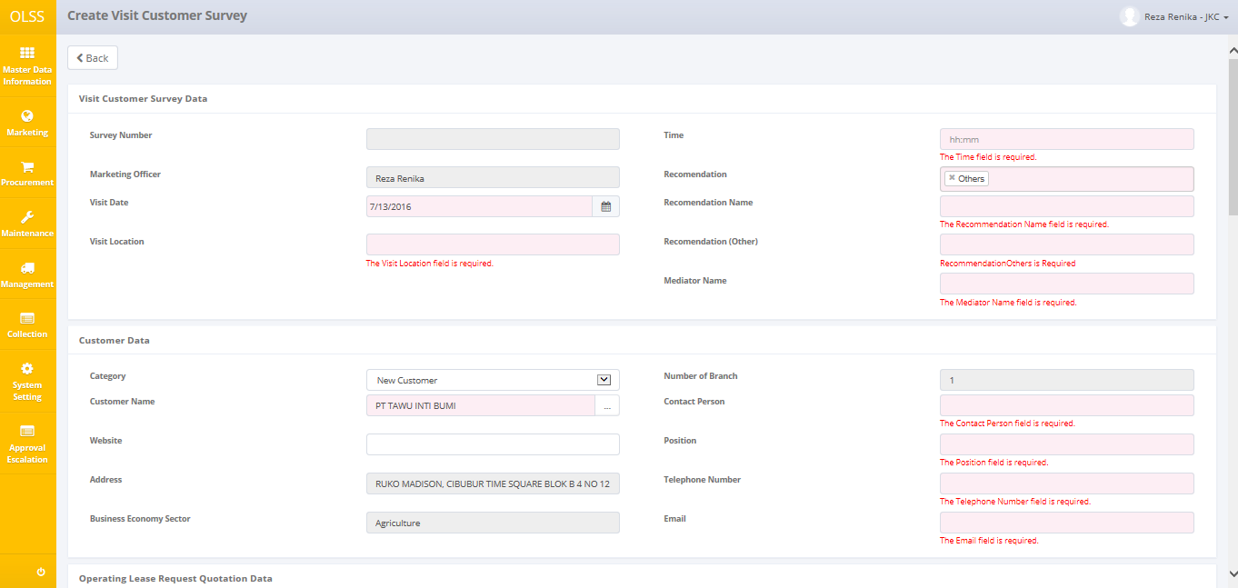

Screen 9: Error notification after save/submit

After clicking **Save as Draft** or **Submit** button, system will notified if it success or failed to save or submit a data. You also have a **Back** button, which redirect you to the previous page, List of Visit Customer Survey page.



Screen 10: Success Notification for Save/Submit

## Edit Visit Customer Survey Data

To edit Visit Customer Survey record, navigate to the List of Visit Customer Survey and click Edit button on the right side of the record. “Edit” can only be clicked on document with status and on document made by the same PIC.

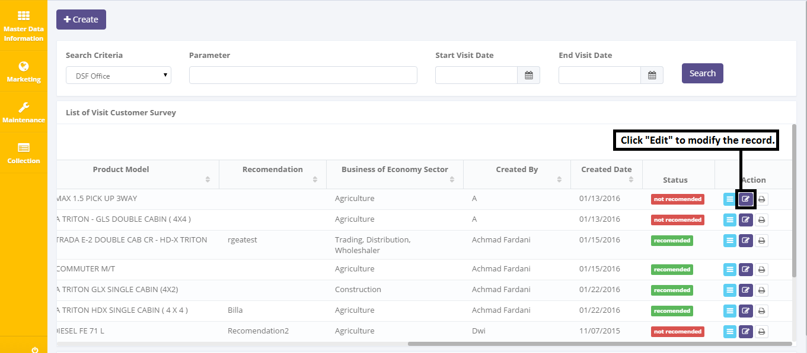

Screen 11: Navigate to Edit from List of Visit Customer Survey Page

The screen below is shown after the Edit button is clicked:

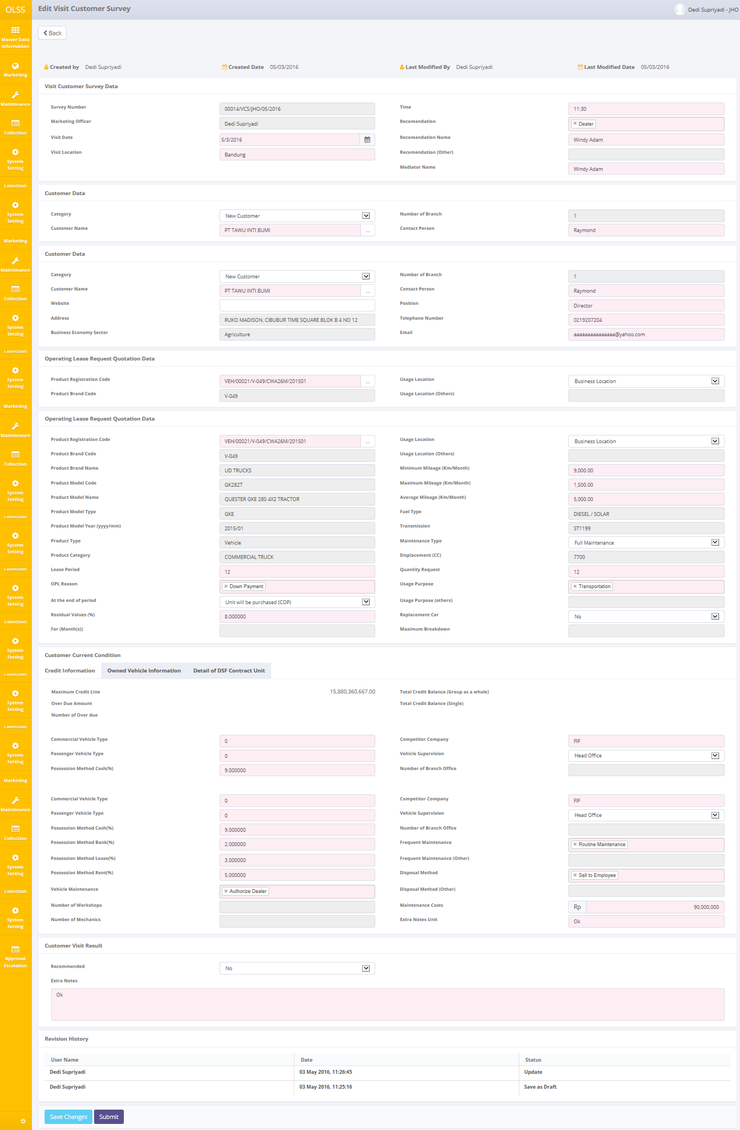

Screen 12: Edit Visit Customer Survey Page

Once the Edit Visit Customer Survey screens open, please change any information just like “Create” Process. There are three buttons that will be displayed on the screen as follows:

1. , on the top-left corner of the screen.
2. , on the bottom-left corner of the screen.
3. , on the bottom-left corner of the screen.

There is a Revision History field on the bottom of the screen, consist of the user information that had make changes to the records. If data already entered on the screen, user can save a data on the system by clicking **Save Changes** button, or **Submit** button. Ensure that you actually want to **Submit** a record, because the records can’t be reserved and update after submitted by user.

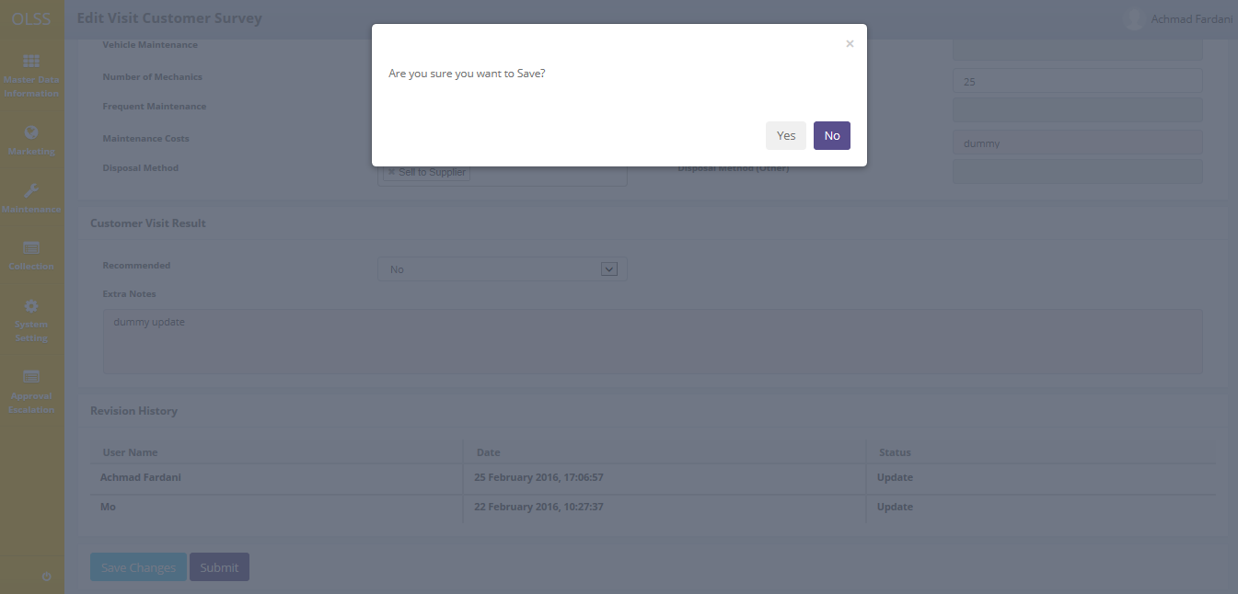

Screen 13: confirmation pop up

There are mandatory fields marked with red background field that should be inputted including; marketing officer, time, recommendation name, recommendation (other), visit date, and so on. It can’t leave as blanks. If you leave them blanks, system will notified it after you clicking **Save Changes** or **Submit** button.



Screen 14: Success Notification for Update

After clicking **Save Changes** or **Submit** button, system will notified if it success or failed to save or submit a data. You also have a **Back** button, which redirect you to the previous page, List of Visit Customer Survey page.

## View Visit Customer Survey Data

To view the records, you can select a record from the customer list page by clicking the action button, on the rightmost column.

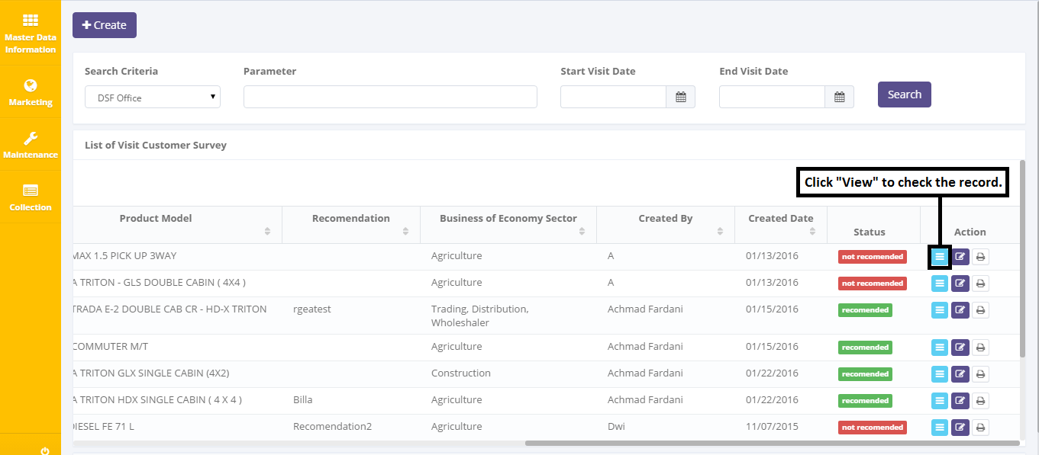

Screen 15: Navigate to View from List of Visit Customer Survey Page

User can view the records but the records cannot be clicked or edited. Here you can see the detail information related with Visit Customer Survey Data, Customer Data, Operating Lease Request Quotation Data, Customer Current Condition, Customer Visit Result, and Revision History.

The screen below is shown after the View button is clicked:

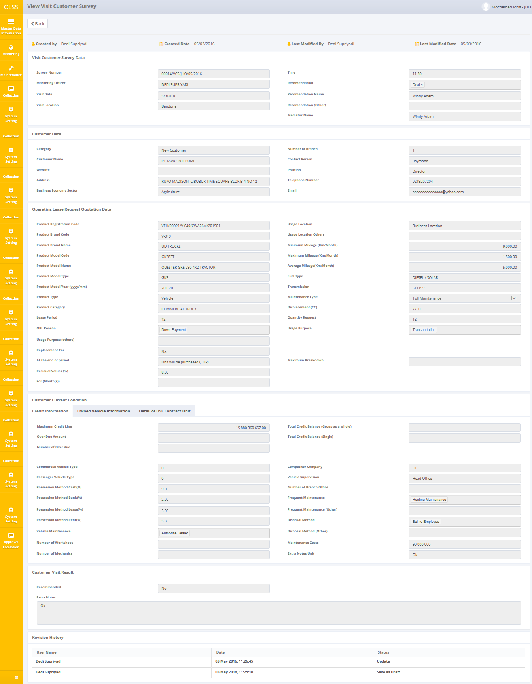

Screen 16: View Detail Visit Customer Survey

After done viewing the records, you can click  button, to redirect you to the previous page, List of Visit Customer Survey Page.

## Print Form Visit Customer Survey

User can also print the records by clicking the button Print Form Visit Customer Survey on the List of Visit Customer Survey screen as shown below:

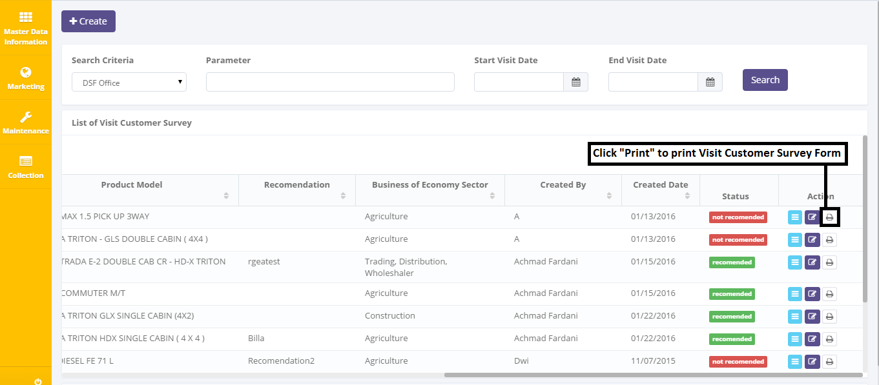

Screen 17: Navigate to Print from List of Visit Customer Survey Page

After clicking the button, a pop up will show to give user confirmation if the user wants to convert the file or not. The convert options are PDF and Excel.

The screen below is shown after the Print Form button is clicked:

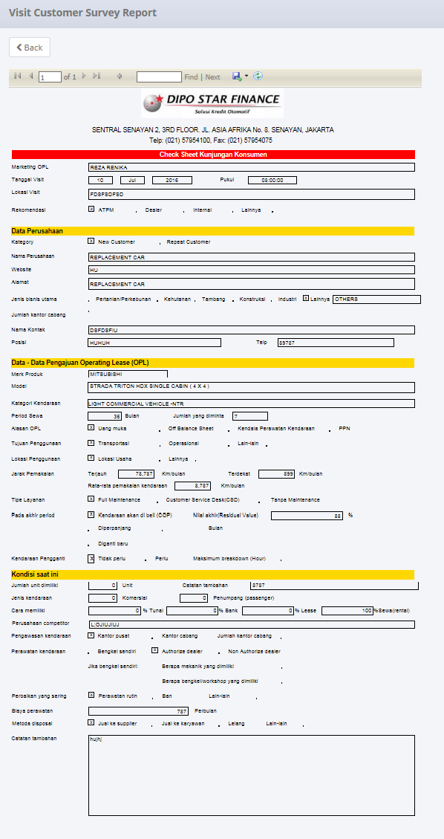

Screen 18: Print Form Visit Customer Survey

## Print Visit Customer Survey Report

Aside from printing Visit Customer Survey, user can print the entire Visit Customer Survey list that has been recorded in the database. To print the report, user can click Print Report button on the bottom of List of Visit Customer Survey Screen.

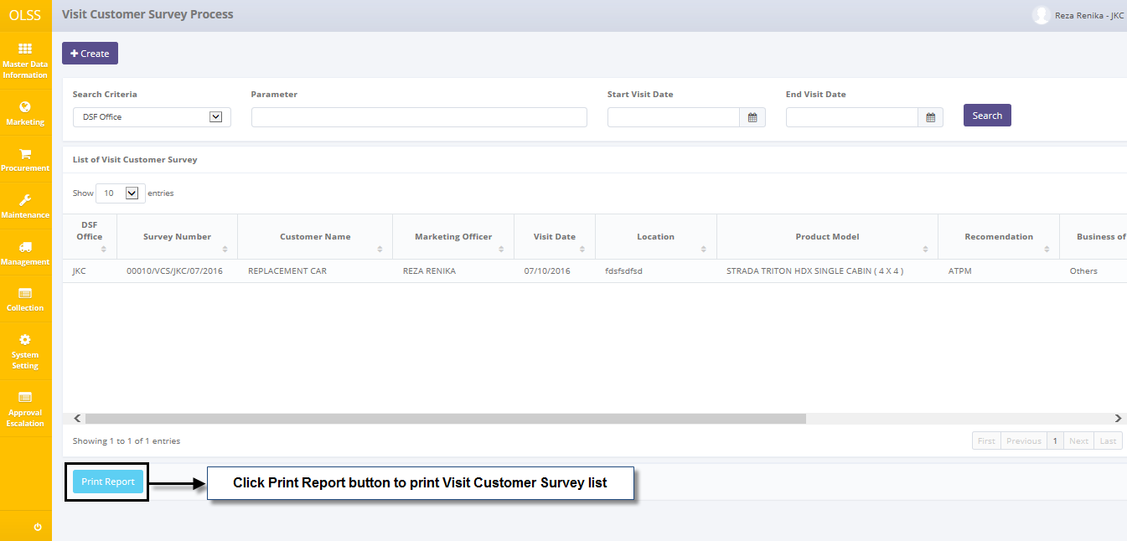

Screen 19: Navigate to Print Report from List of Visit Customer Survey Page

The report is downloaded after the Print Report button is clicked:

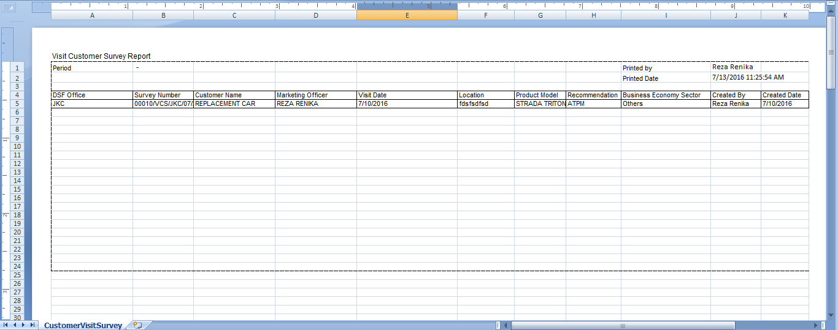

Screen 20: Visit Customer Survey Report